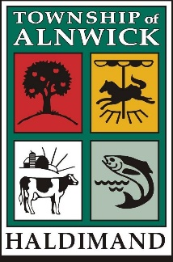
2022 Civic Awards
Nomination Package

General Information

- Nominees must be volunteers. Any remuneration of any kind for the activity in which the person is involved will make the nomination void.

- A person may be nominated in more than one category and a separate nomination form must be completed for each category. However, a nominated individual will only be recognized once within a year in a specific category.

- The activity for which a nominee is considered must be of direct benefit to that field with the Township of Alnwick/Haldimand.

- Any persons contributing to the betterment and/or bringing recognition to the Township of Alnwick/Haldimand may be nominated for individual awards.

- Please ensure spelling of all names are correct on the Nomination Form. If a team is nominated please include a team list along with the Coach’s name, address and telephone number. A letter of support confirming the volunteer hours and contribution made must be included and attached to any nomination.

- Completed Nomination Forms must be received by April 30th of each year to be eligible for consideration.

- Completed Nomination Forms will be accepted via email, fax, personal delivery or mail.

- Decisions are made solely at the discretion of the Council of the Township of Alnwick/Haldimand.

2022 Civic Awards
CHECK LIST

It’s as easy as 1, 2, 3 …

1… Complete the Nomination Form. Ensure the correct spelling of all names and fully complete all sections.

2… Enclose a Resume of the individual or detailed outline of the organization for which the nomination applies. (Depending on the nomination, you may also need to include a letter of verification from a recognized representative of the organization/group relevant to the nomination.)

3… Enclose two (2) Letters of Support for
the nomination of Citizen and Jr. Citizens of the year only.

That’s it!

Thank you for taking the time to complete a nomination for the 2022 Civic Awards.

PLEASE NOTE:

Only nominations that are correctly completed and with the appropriate attachments will be considered – so be sure that everything on this list is included in your nomination package!

The Township of Alnwick/Haldimand is not responsible for letters and/or awards returned as undeliverable to the address provided by the nominator.

